Name

Mathematics Stage 4
Probability

Book 1 |  | Version: 260911  Feedback:  https://MrDingMaths.com
Contents
Syllabus Content 2
Outcomes and Sample Space 3
Describing Probability 5
Calculating Probability 9
Expected Frequency 19
Relative Frequency 23
Law of Large Numbers 31
Complementary Events 33
Using the Complement in Probability Problems 35

Syllabus Content
MA4-PRO-C-01 solves problems involving the probabilities of simple chance experiments
Determine probabilities for chance experiments
- List the sample space for chance experiments
- Express the probability of an event, which has a finite number of equally likely outcomes, as $P\left(event\right)=\frac{number of favourable events}{total number of outcomes}$
- Recognise that probabilities range from 0 (impossible) to 1 (certain) and that equally likely outcomes have equal probabilities
- Verify that the total of the probabilities of all possible outcomes of an event is 1
- Identify and describe theoretical (expected) probabilities as being the likelihood of outcomes occurring under fair or unbiased conditions
- Explain that observed probability is the relative frequency resulting from repeated trials of a simulation and determine observed probabilities
- Explore relative frequencies by using a random number generator to repeat a chance experiment a number of times
Determine probabilities for complementary events
- Identify and describe the complement of an event
- Verify that the sum of the probability of an event and its complement is a total of 1
- Solve problems involving the probability of complementary events
- Represent the possible outcomes for complementary events in various forms

Outcomes and Sample Space

- Experiments and Sample Space
An experiment in probability is any activity that produces results called outcomes.
Each time we repeat an experiment, we call it a trial.
We cannot predict the exact result beforehand. This uncertainty is called randomness.
The sample space $S$ is the set of all possible outcomes for an experiment, without repeats.

- Example list the sample space of an experiment.
  A coin is flipped.  - List all the outcomes.  $Heads, Tails$  - List the sample space.  $S=\{Heads,Tails\}$  - Is each outcome equally likely? Yes. | 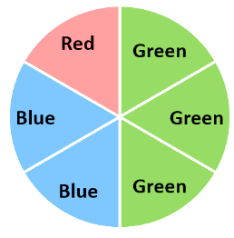  Consider the spinner.  - List all the outcomes.  $G, G, G, B, B, R$  - List the sample space.  $S=\{G, B, R\}$  - Is each outcome equally likely? No.

- Practice
A standard 6-sided die is rolled.  - List the outcomes  1, 2, 3, 4, 5, 6  - List the sample space.  {1, 2, 3, 4, 5, 6}  - Is each number equally likely?  Yes | A jar contains 2 red, 3 yellow, and 4 blue lollies. One is picked out at random.  - List the outcomes.  R ,R, Y, Y, Y, B, B, B, B  - List the sample space.  {R, Y, B}  - Is each colour equally likely?  No

- Key Ideas
- An outcome is a possible ………………… of a chance experiment.
- The sample space lists ………… possible outcomes, without repeats.

Foundation
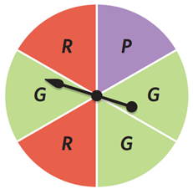
- This spinner is spun. The colour of the sector is recorded.
  - List all the outcomes
P, G, G, R, G, R
  - List the sample space.
$$\left\{R, P, G\right\}$$
  - Is each colour equally likely?
no

- This spinner is spun. The colour of the sector is recorded.
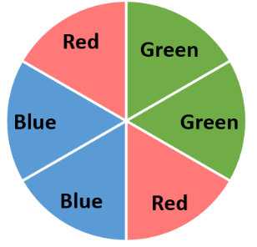
  - List all the outcomes
G, G, R, B, B, R
  - List the sample space.
$$\left\{G, R, B\right\}$$
  - Is each colour equally likely?
yes
  - Is purple a possible outcome?
no
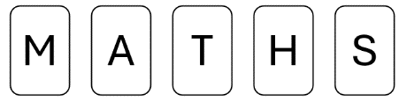
- The letters M A T H S are written on cards and put in a hat.
One card is selected at random.
  - List each outcome of this chance experiment.
M, A, T, H, or S
  - List the sample space.
$$\left\{M, A, T, H, S\right\}$$
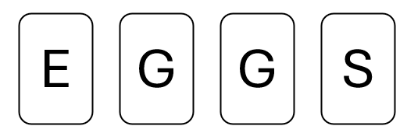
  - Is each letter equally likely?
yes

- The letters E G G S are written on cards and put in a hat.
One card is selected at random.
  - List each outcome of this chance experiment.
E, G, G, S
  - List the sample space.
$$\left\{E, G, S\right\}$$
  - Is each letter equally likely?
no

- A ball is selected at random from a bag containing 1 black, 1 white and 1 green ball.
  - List all the outcomes of this chance experiment.
B, W, G
  - List the sample space.
$$\left\{B, W, G\right\}$$
  - Is each colour equally likely?
yes

- A ball is selected at random from a bag containing 2 black, 3 white and 1 green ball.
  - List all the outcomes of this chance experiment.
B, B, W, W, W, G
  - List the sample space.
$$\left\{B, W, G\right\}$$
  - Is each colour equally likely?
no

Describing Probability

- Events
- An event is a collection of one or more outcomes.
- We can describe the chance of an event using these terms:
- Equally likely means two or more events have the same chance of happening.

Impossible  Never happens | Unlikely  Happens less than half the time | Even Chance  Happens exactly half the time | Likely  Happens more than half the time | Certain  Always happens

- Describe probability of outcomes
Circle impossible, unlikely, even, likely, or certain for these events.
- Tossing 6 heads in a row on a fair coin. | 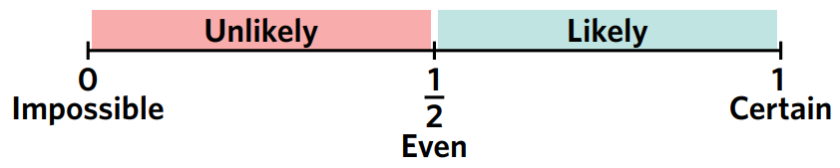  - 60 seconds passing in one minute.
- Rolling an even number on a standard die. | - A person jumping over the moon.
- Flipping a coin and getting tails. | - Picking whether a person has an object in their left or right hand.
- The sun rises tomorrow morning. | - Winning the lottery.

Foundation
- State whether these events are impossible, unlikely, even chance, likely, or certain.
  - Rolling a fair 6-sided die and landing on a 4.
unlikely
  - The time being 11:00 am one hour after 10:00 am.
certain
  - Getting 13 questions correct on a test containing 10 questions.
impossible
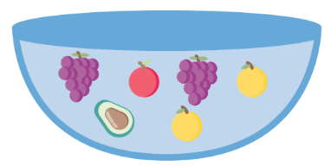
  - Picking a banana at random out of the following fruit bowl.

unlikely
- Consider a fair 6-sided die with the numbers 1 to 6 on it.
Answer true or false to each of the following.
  - Rolling a 3 is unlikely.
true
  - Rolling a 5 is likely.
false
  - Rolling a 4 and rolling a 5 are equally likely events.
true
  - Rolling an even number is likely.
false
  - There is an even chance of rolling an odd number.
true
  - There is an even chance of rolling a multiple of 3
false
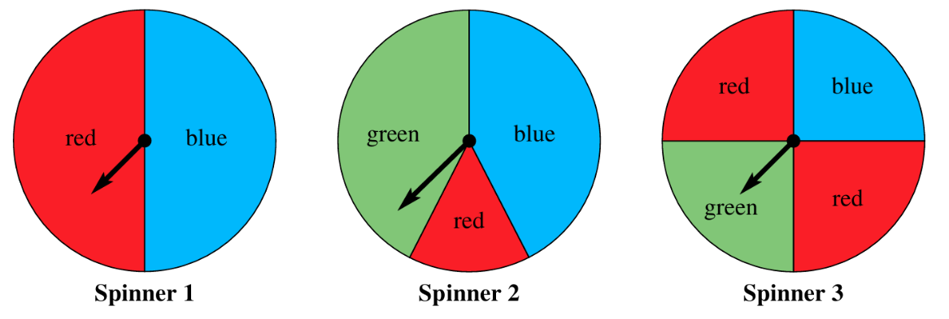
- Match each spinner with the description.

  - Has an even chance of red, but blue is unlikely.
Spinner 3
  - Blue and green are equally likely, but red is unlikely.
Spinner 2
  - Has an even chance of blue, and green is impossible.
Spinner 1

Development
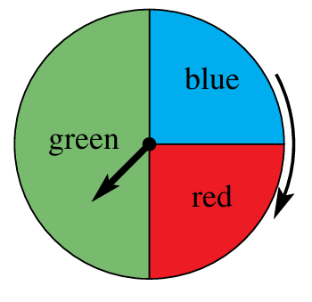
- Consider the spinner shown, which is spun and could land with the arrow pointing to any of the three colours.

  - State whether each of the following is true or false.
    - There is an even chance that the spinner will point to green.
true
    - It is likely that the spinner will point to red.
false
    - It is certain that the spinner will point to purple.
false
    - It is equally likely that the spinner will point to red or blue.
true
    - Green is twice as likely as blue.
true
  - Use the spinner to give an example of:
    - an impossible event
any colour other than green, blue or red
    - a certain event
landing on either green, blue, or red
    - a likely event
landing on green or blue / landing on green or red
    - two events that are equally likely
landing on blue, landing on red
- The spinner below is spun.
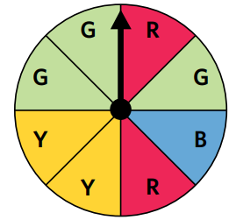
  - List all the possible outcomes
R, R, G, G, G, B, Y, Y
  - List the sample space
$$\left\{R, G, B, Y\right\}$$
Answer true or false to the following statements.
  - Green is three times more likely than red.
false
  - Yellow and green have equal chance.
false
  - Yellow and red have equal chance.
true
  - Green is likely.
false
  - Green is unlikely.
true
  - Red is twice as likely as blue.
true

Mastery
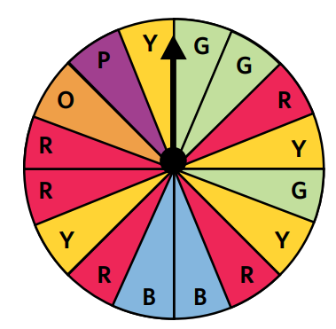
- Fill in the blanks for the statements related to the spinner.

  - Landing on green is …………… times as likely than landing on purple.
3
  - Landing on red is ………… times as likely than landing on orange.
5
  - Landing on ………… is two times as likely than landing on blue.
yellow
  - Landing on orange has the same chance as landing on ………….
purple
  - Landing on either red or ………… has an even chance of occurring.
green
  - Landing on red has the same chance as landing on either green or …………
blue
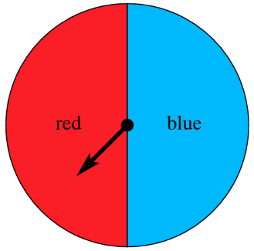
- Explain why tossing a coin and this spinner are equivalent chance experiments.
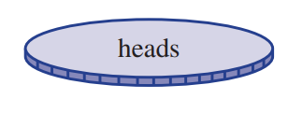

Both have only two outcomes that are equally likely
- Explain the difference between an outcome having even chance and two or more outcomes being equally likely.

Even chance means a probability of exactly 50%.
Equally likely means that multiple outcomes have the same probability as each other, but that probability can be any value, not necessarily 50%.
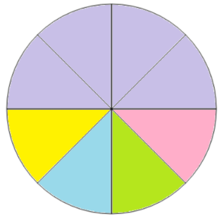
- Create a spinner with all these conditions.
- 8 equally sized sectors.
- 5 colours, purple, pink, green, blue, yellow.
- An even chance of landing on purple.
- The chance of blue and yellow are the same.

Calculating Probability

- Theoretical Probability
- Theoretical probability is a number showing how likely an event is.
- $P(event)$ means "probability of the event happening".
$$P\left(event\right)=\frac{number of favourable outcomes}{total number of outcomes}$$
- Each outcome must be equally likely.
- The probability of an event is always between 0 and 1.
- All probabilities add up to 1.

- Example Calculate theoretical probability
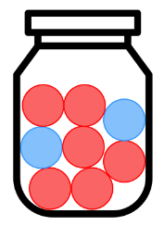
A jar of marbles contains
6 red marbles and 2 blue marbles.

Find the probability of picking a red marble.  $$P\left(red\right)=\frac{6}{8}=\frac{3}{4}$$ | Find the probability of picking a blue marble.  $$P\left(black\right)=\frac{2}{8}=\frac{1}{4}$$

- Guided Practice
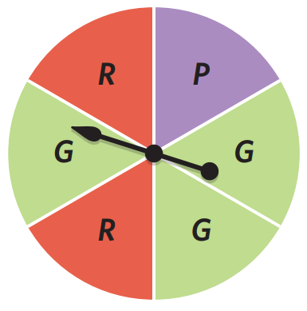
A spinner with equal sections is shown.
Find:

- $P(Green)$  $$\frac{1}{2}$$ | - $P(Purple)$  $$\frac{1}{6}$$ | - $P(Red)$  $$\frac{1}{3}$$ | - Sum of probabilities  1
A jar contains 8 blue, 4 orange, and 6 red marbles. Calculate:

- $P(blue)$  $$\frac{4}{9}$$ | - $P(orange)$  $$\frac{2}{9}$$ | - $P(red)$  $$\frac{1}{3}$$ | - $P\left(blue\right)+P\left(orange\right)+P(red)$  1

- Key Ideas
- We can express probability as a number between ……… and ………
- The probability of every possible outcome must sum to …………

Foundation
- Calculate the probability of these events.
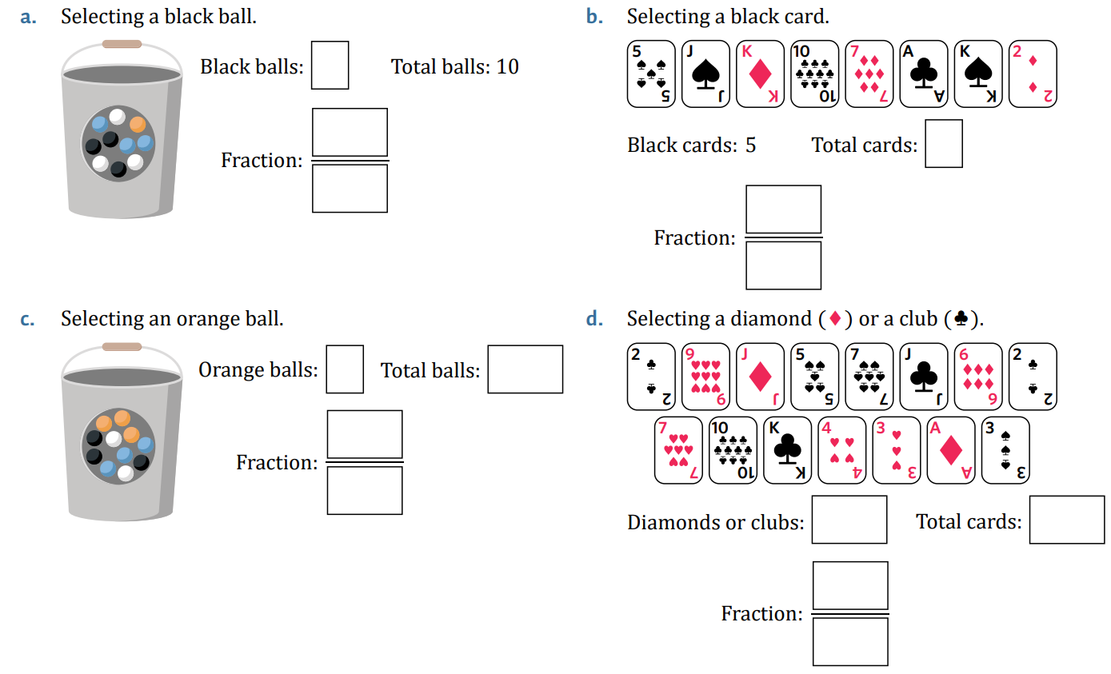  - Event: selecting a black ball  $$\frac{3}{10}$$ | - Event: selecting a black card  $$\frac{5}{8}$$
- The spinner below is fair. Find the probability of each event.
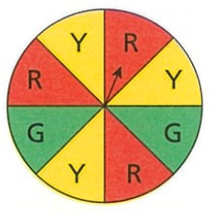
  - …… out of …… sections are red. $P(red)=$
$$\frac{3}{8}$$
  - …… out of …… sections are green. $P\left(green\right)=$
$$\frac{2}{8}=\frac{1}{4}$$
  - …… out of …… sections are yellow. $P\left(yellow\right)=$
$$\frac{3}{8}$$
  - Which events are equally likely?
Landing on Red, Landing on Yellow
- Consider a fair six-sided die.
  - List all the outcomes.
$$\left\{1, 2, 3, 4, 5, 6\right\}$$
  - List the odd numbers on the die.
$$\left\{1, 3, 5\right\}$$
  - Calculate the probability of rolling an odd number.
$P\left(odd\right)=$
$$\frac{3}{6}=\frac{1}{2}$$
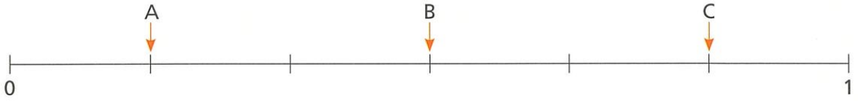
- Here is a probability scale. Three probabilities are labelled A, B and C.
A fair six-sided dice numbered 1 to 6 is rolled.
Write down the letter that matches each of these probabilities.

  - The probability of rolling an even number
B
  - The probability of rolling a 3.
A
  - The probability of rolling a number greater than 1.
C
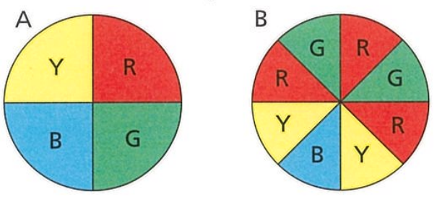
- Here are two fair spinners.

Jackson says, “The chance of spinning blue on each spinner is the same because there is one blue section on each spinner.” Explain why Jackson is incorrect.

The size of the section are different.
For spinner A, $P\left(B\right)=$ $\frac{1}{4}$, for spinner B, $P\left(B\right)=$ $\frac{1}{8}$
- Which box you do you have more chance of picking a red marble out of?
Determine the answer by calculating the probability.
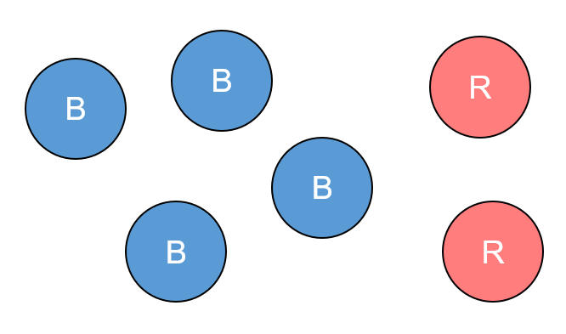  - Box A  $$\frac{2}{6}=\frac{1}{3}$$ | 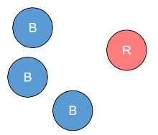  Box B  $$\frac{1}{4}$$ | More chance of red:  A
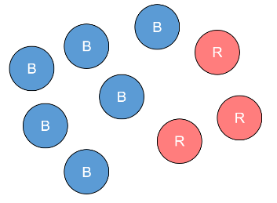  - Box A  $$\frac{3}{9}=\frac{1}{3}$$ | 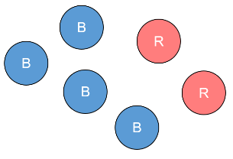  Box B  $$\frac{2}{6}=\frac{1}{3}$$ | More chance of red:  Both have same chance

- A bag contains 8 counters. 5 of the counters are red and 3 of the counters are blue.
On the probability scale, mark:
- $P(red)$ | - $P(green)$ | - $P(blue)$

P(Green) P(blue) P(red)

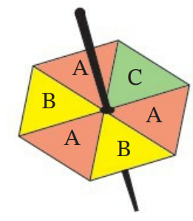
- The spinner is spun. Calculate:
- $P\left(A\right)=$  $$\frac{1}{2}$$ | - $P\left(C\right)=$  $$\frac{1}{6}$$ | - $P\left(B\right)=$  $$\frac{1}{3}$$ | - $P\left(D\right)=$  0
- Do all probabilities sum to 1?

yes
- Which event is the most likely?

Getting an A

- A jar of lollies contains 6 red, 4 green, 7 yellow, and 3 blue lollies.
A lolly is selected from the jar at random.
Calculate the probabilities of these events as fractions, decimals, and percentages.
 | Fraction | Decimal | Percentage
- $P\left(green\right)$ | $$\frac{4}{20}=\frac{1}{5}$$ | 0.2 | 20%
- $P(yellow)$ | $$\frac{7}{20}$$ | 0.35 | 35%
- $P\left(red\right)$ | $$\frac{6}{20}=\frac{3}{10}$$ | 0.3 | 30%
- $P(blue)$ | $$\frac{3}{20}$$ | 0.15 | 15%
- Do all probabilities sum to 1?
yes
- A bag of marbles contains 3 red marbles, 2 green marbles and 5 blue marbles.
A marble is chosen at random.
  - What is the probability that a red marble is chosen?
$$\frac{3}{10}$$
  - Explain why your answer to part a is not $\frac{1}{3}$.
Each colour is not equally likely
  - What is the probability that a blue marble is chosen? Answer as a percentage.

$$50\%$$

Development
- For each of these scenarios, calculate the probability of choosing a grey counter as a decimal (you may use a calculator)
0.5 | 1
0.625 | $$0.\dot{6}$$
$$0.\overline{714285}$$ | 0.5
$$0.\dot{6}$$ | 0.5
1 | $$0.6$$

  - What two numbers must the probability of a number be between?
0 and 1
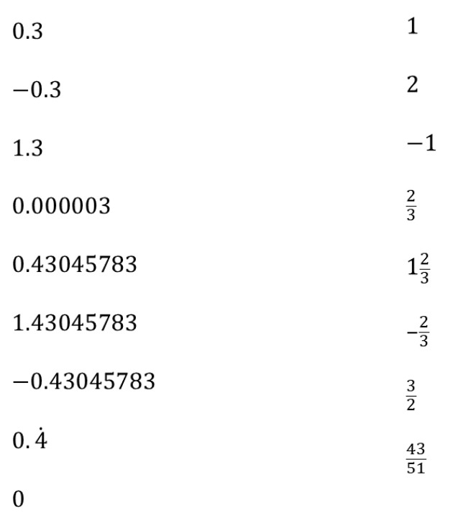
  - Circle which of these numbers could represent a probability.

0.3, 1, 0.43045783
$$0.000003,\frac{2}{3}, 0.\dot{4},\frac{43}{51}$$
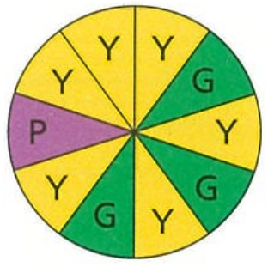
- Consider this spinner. Mark on the number line the probability of spinning:
- Yellow | - Green | - Purple

$P\left(P\right)$ $P\left(G\right)$ $P\left(Y\right)$

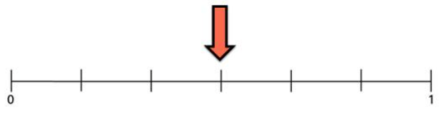
- Tom and Katie want to place counters in a bag so the probability of picking a red is here on the number line.

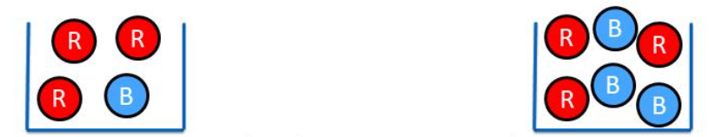
Tom’s bag Katie’s bag

Who do you agree with, and why?
The arrow points to $\frac{1}{2}$
Katie is correct as half the counters in her bag are red.
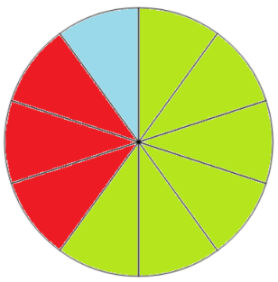
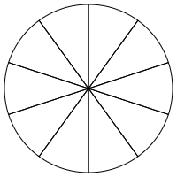
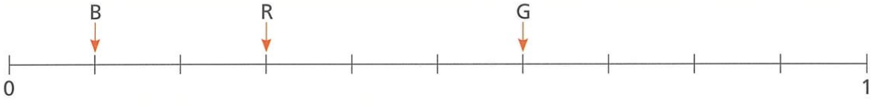
- A fair spinner is split into 10 sections that are either red, blue or green.
The probability of the spinner landing on each colour is shown on the scale.

Complete the diagram to show what the spinner might look like.

- NAPLAN A
A standard six-sided die is rolled. What is the probability that it lands on a factor of 4?
Factors of 4 are 1, 2, 4
$$\frac{3}{6}=\frac{1}{2}$$
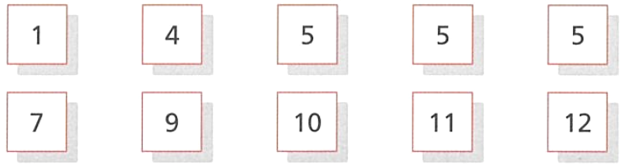
- Mandy puts these numbers cards into a bag.

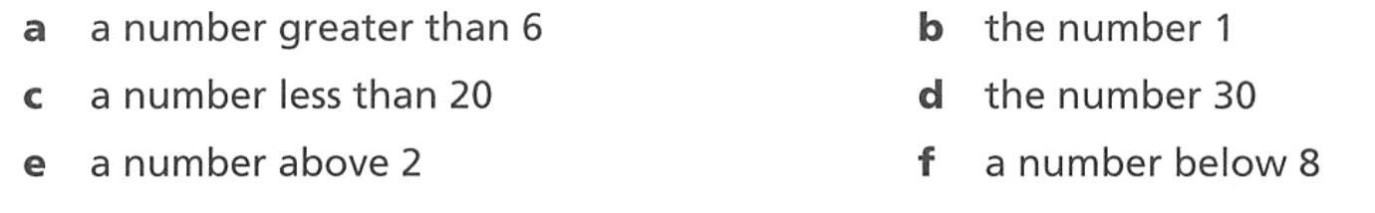
She removes a card without looking. First calculate the probability then use an appropriate word to describe the probability of each outcome:
$$\frac{1}{2}, even chance$$ | $$\frac{1}{10}, unlikely$$
$1$, certain | 0, impossible
$$\frac{9}{10}, likely$$ | $$\frac{3}{5}, likely$$

- Some cards have some letters and symbols on them.
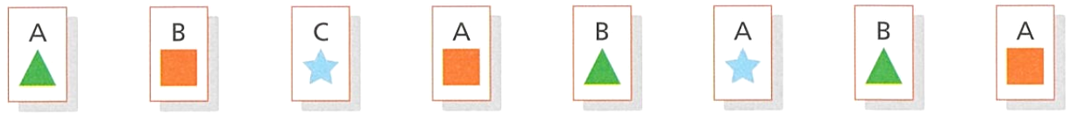

A card is chosen at random. What is the probability that the card:
- has the letter A on it  $$\frac{1}{2}$$ | - has a square on it  $$\frac{3}{8}$$ | - has both an A and a square on it  $$\frac{1}{4}$$
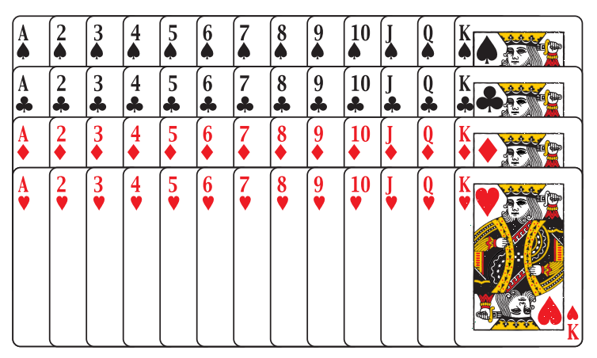
- Adam has spread out a pack of playing cards.
He picks a card at random.
Hearts and diamonds are red.
Clubs and spades are black.
Picture cards are king, queen and jack.
Find:
- P(spade)  $$\frac{1}{4}$$ | - P(4 of hearts)  $$\frac{1}{52}$$ | - P(club)  $$\frac{1}{4}$$
- P(black 10)  $$\frac{1}{26}$$ | - P(ace)  $$\frac{1}{13}$$ | - P(picture card)  $$\frac{3}{13}$$
- P(5 or 6)  $$\frac{2}{13}$$ | - P(green card)  0 | - P(not a picture card)  $$\frac{10}{13}$$

- 20000 people enter a competition. There are going to be 10 winners.
Jakub says that there is less than a 1% chance of winning the competition. Is Jakub correct?

Yes, $\frac{10}{20 000}$ is $\frac{1}{2000}$, which is less than 1%
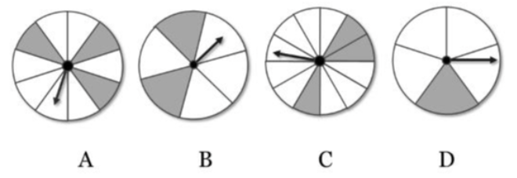
- Which spinner has the highest probability of landing on grey?

$$A:\frac{3}{10}=0.3$$
$$B=\frac{2}{5}=0.4$$
$$C=\frac{3}{12}=0.25$$
$$D=\frac{1}{5}=0.2$$
Spinner B

Mastery
- A bag contains various coloured marbles. Some are red, some are blue, some are yellow and some are green. You are told that P(red) = $\frac{1}{2}$ , P(blue) = $\frac{1}{4}$ and P(yellow) = $\frac{1}{6}$ .
You are not told the probability of selecting a green marble.
  - If there are 24 marbles:
    - Find how many marbles there are of each colour.
Red = 12, Blue = 6, Yellow = 4, Green = 2
    - What is the probability of getting a green marble?
$$\frac{1}{12}$$
  - If there are 36 marbles:
    - Find how many marbles there are of each colour.
Red = 18, Blue = 9, Yello = 6
    - What is the probability of getting a green marble?
$$\frac{1}{12}$$
  - What is the minimum number of marbles in the bag?
LCM of 2, 4, 6, is 12

- NAPLAN A
Sharon made 24 milkshakes at a party. The milkshakes were either vanilla or chocolate.
All the milkshakes were served in an aluminium cup and looked the same.
Murray took one milkshake and had a 1 in 8 chance of taking a vanilla milkshake.
How many chocolate milkshakes did Sharon make?

$$Vanilla: \frac{1}{8}×24=3$$
So, there are 24 – 3 = 21 choccy milkshakes
- Ally has 20 numbered cards.
The probability of choosing a card less than 3 is shown on the scale.

How many more cards less than 3 do you need to add so that the probability of getting a number less than 3 is 0.5? Show all your working.

Currently the probability is 0.3, $0.3×20=6$
There are 6 cards less than 3.
Currently the fraction is $\frac{6}{20}$
$$\frac{6+x}{20+x}=\frac{1}{2}$$
Need to add 6 more cards to make $\frac{12}{24}=\frac{1}{2}$
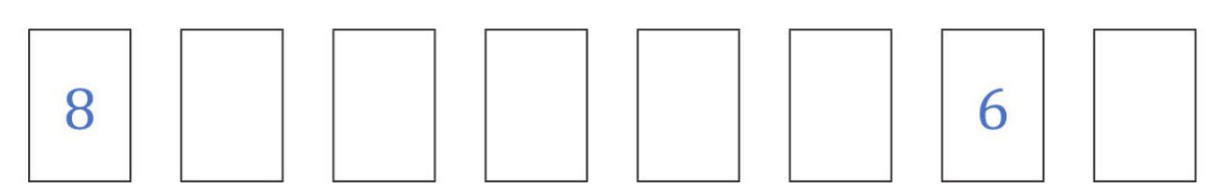
- Elliott has eight numbered cards.

One of the cards is chosen at random. Elliott says:
- The probability of an 8 is $\frac{1}{4}$
- The range of numbers is 5.
- The probability of a number greater than 10 is 0.
- The probability of 7 is $\frac{1}{2}$
Find the six missing numbers.
Missing numbers are 8, 3, 7, 7, 7, 7
- A bag contains some green marbles, blue marbles, and white marbles.
- The probability of picking blue is $\frac{1}{2}$
- There are 5 green marbles.
- There are 4 white marbles.
How many blue marbles are there?

The 5 green and 4 white marbles make up the other $\frac{1}{2}$ of the bag. So, 9 blue.
- Construct a spinner with 4 colours (red, green, blue, and yellow) that meets these conditions:
- The probability of landing on blue is $\frac{1}{3}$
- There is an equal chance of landing on red and green.
- Landing on yellow is twice and likely to occur as landing on red.

Let $P\left(R\right)=P\left(G\right)=x$
$$P\left(B\right)+P\left(R\right)+P\left(G\right)+P\left(Y\right)=1$$
$$\frac{1}{3}+x+x+2x=1$$
$$x=\frac{1}{6}$$
Therefore the spinner should be
$$\frac{1}{3}Blue,\frac{1}{6} Red,\frac{1}{6} Green,\frac{1}{3} Yellow$$
- 2011 HSC Standard 2 Band 4
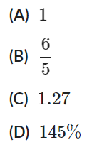
Which of the following could be the probability of an event occurring?

A

- 2008 HSC Standard 2 Band 4
A bag contains some marbles.
The probability of selecting a blue marble at random from this bag is three eighths.
Which of the following could describe the number of marbles in the bag?
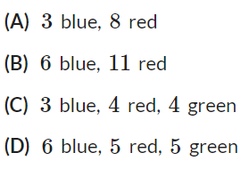

D
For option D,
$$P\left(B\right)=\frac{6}{16}=\frac{3}{8}$$
- 2005 HSC Standard 2 Band 4
Four radio stations reported the probability of rain as shown in the table.
Which radio station reported the highest probability of rain?
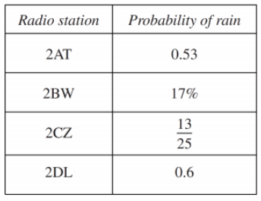

Convert all probabilities to decimals.
2DL has the highest probability.
- A dartboard is shown. Juna throws a dart, and it hits the board.
What is the probability of it landing in the triangular area?
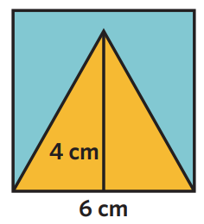

$$P\left(triangle\right)=\frac{Triangle Area}{Square Area}=\frac{\left(\frac{\left(4\right)\left(6\right)}{2}\right)}{6^{2}}=\frac{12}{36}=\frac{1}{3}$$

Expected Frequency

- Expected Frequency
- A trial is a repetition of a chance experiment; rolling a die 100 times means 100 trials.
- Frequency is how often something happens.
- Expected frequency is how many times we think an event will happen in certain trials.
- Actual frequency may differ from expected frequency due to randomness.
- To calculate the expected frequency:
- Find the probability.
- Multiply number of trials by the probability.
$$Expected freq=Number of trials×Probability \\ f=np$$

- Example Calculate expected frequency of an outcome
A fair coin is flipped 100 times. How many times would you expect it to land on heads?
1. $P\left(heads\right)=$ $\frac{1}{2}$
2. $f=np$ $=100×$ $\frac{1}{2}$ $=50$

- Guided Practice
A fair die is rolled.
- What is the probability of rolling a 4?  $$\frac{1}{6}$$ | - What is the expected frequency of it landing on a 4 in 120 trials?  $$20$$
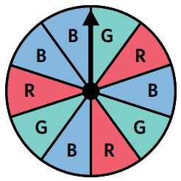
How many times would you expect the spinner to land on blue in 20 spins?

8

- Key Ideas
- We calculate the expected frequency of an event by multiplying its …………………… by the number of trials.

Foundation
- Calculate the expected frequency of:
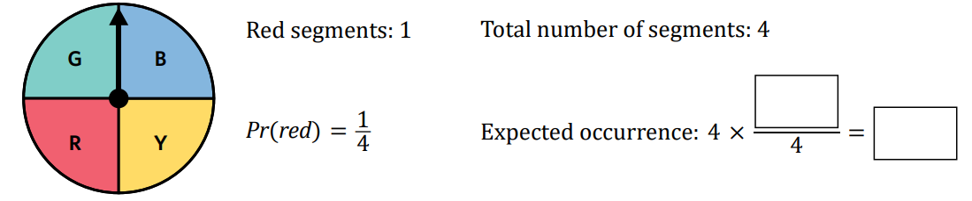
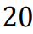
  - Landing on red in 20 spins.

5
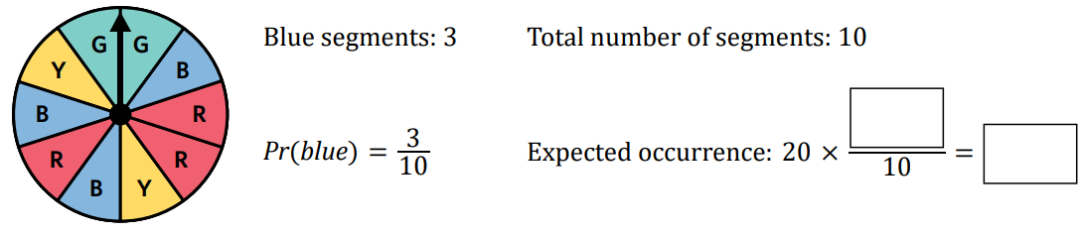
  - Landing on blue in 20 spins.

6
- A fair 10-sided die has each face numbered from 1–10.
Calculate the expected frequency of each event from the given number of trials.
- Rolling a 1 (30 trials)  $P\left(Rolling 1\right)=$ ……………………  Expected freq $=$ ………… $×$ …………  $=$ …………  $$\frac{1}{10}×30=3$$ | - Rolling an odd number (50 trials).  $P\left(Rolling odd\right)=$  Expected freq $=$  $$\frac{1}{2}×50=25$$
- Rolling a 12 (100 trials).  0 | - Rolling a number 8 or greater (150 trials).  $$\frac{3}{10}×150=45$$
- Rolling a 2, 4, 6 or 8 (200 trials).  $$\frac{4}{10}×200=80$$ | - Rolling a multiple of 3 (600 trials).  $$\frac{3}{10}×600=180$$

- A fair 10-sided die has faces with the numbers: 3 3 3 5 8 8 8 9 10 10.
  - Calculate the theoretical probability, as a fraction, of rolling a 3.
$$\frac{3}{10}$$
  - Calculate the expected number of occurrences of rolling a 3 from 20 rolls.
$$\frac{3}{10}×20=6$$
  - Calculate the theoretical probability, as a decimal, of rolling an odd number.
$$\frac{5}{10}=0.5$$
  - Calculate the expected number of occurrences of rolling an odd number from 150 rolls.

$$0.5×150=75$$

  - If I throw a fair coin 10 times, how many times would you expect it to land on heads?
5
  - If I throw a fair coin 20 times, how many times would you expect it to land on heads?
10
  - If I throw a fair coin 60 times, how many times would you expect it to land on heads?
30
  - If I throw a fair coin 600 times, how many times would you expect it to land on heads?
300
  - If I roll a fair dice 600 times, how many times would you expect it to land on the number 1?
100
  - If I roll a fair dice 300 times, how many times would you expect it to land on the number 1?
50
  - If I roll a fair dice 150 times, how many times would you expect it to land on the number 1?
25
  - If I roll a fair dice 150 times, how many times would you expect it to land on the number 2?
25
  - If I roll a fair dice 1500 times, how many times would you expect it to land on the number 2?
250
  - If I throw a fair coin 1500 times, how many times would you expect it to land on heads?
750

Development
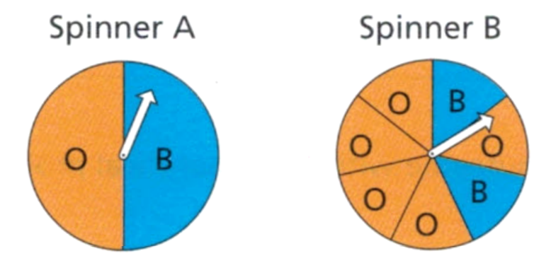
- Each spinner is spun 1400 times.
Estimate how many times
  - spinner A will land on blue
700
  - spinner B will land on orange.
1000
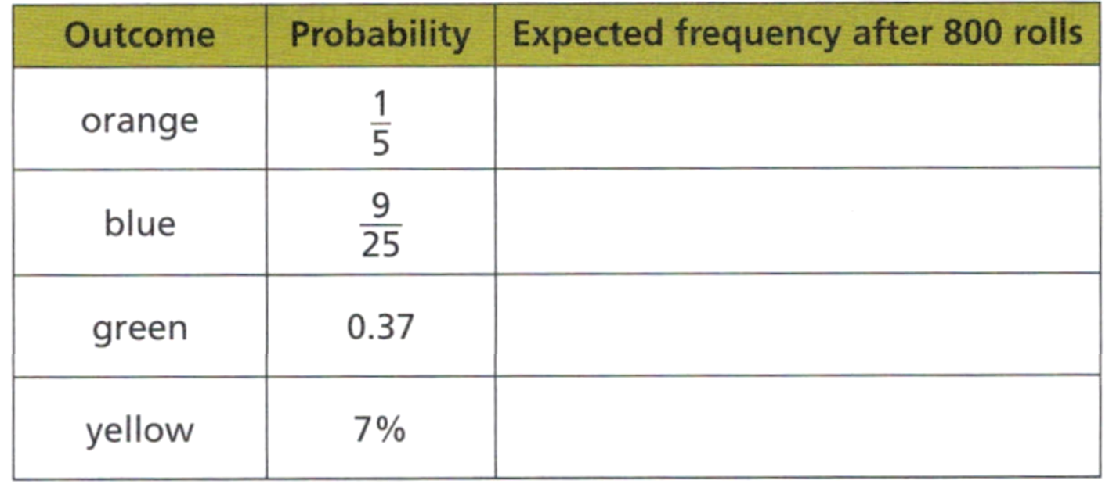
- A spinner is divided into sections, with colours orange, blue, green and yellow.
Complete the table.
160

288

296

56

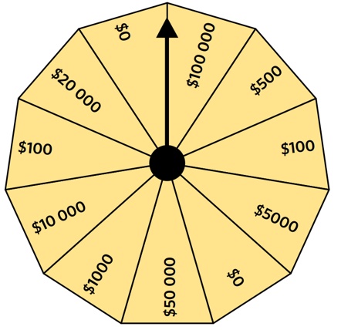
- Wheel of Fortune is a quiz show where winners get to spin a wheel to determine their prize. The spinner is fair and has an equal chance of landing on each segment.
  - What is the probability that a winner gets a prize more than $1000?
$$\frac{5}{11}$$
  - In 110 spins of the Wheel of Fortune, how many winners are expected to receive a prize that is $5000 or less?
70
  - Out of the first 110 winners, 104 have received a prize that is $5000 or less.
Is there a reason to believe that the wheel may be rigged?

It seems likely that the wheel may be rigged as 104 is very different to the 70 that we expect.
- 2018 HSC Standard 2 Band 3
An experiment has three distinct outcomes, A, B and C. Outcome A occurs 50% of the time. Outcome B occurs 23% of the time.
What is the expected number of times outcome C would occur if the experiment is conducted 500 times?

$0.27×500=$135 times

Relative Frequency

- Relative Frequency
- Theoretical probability is what we calculate.
- Relative frequency, or observed probability, is what actually happens in an experiment.
- It is the frequency related to total trials.
$$Relative frequency=\frac{Frequency of outcome }{Total trials} \\ Frequency of outcome=Relative frequency×Total trials$$

- Example Calculate relative frequency
A die is rolled 10 times. These numbers came up:
$$1, 4, 1, 3, 3, 1, 4, 3, 2, 3$$
Find the relative frequency of rolling a 3.  $$rf=\frac{Frequency of 3}{Total trials}=\frac{4}{10}=\frac{2}{5}$$ | Find the relative frequency of rolling an even number.  $$rf=\frac{Frequency of even}{Total trials}=\frac{3}{10}$$
If the same experiment were repeated with 500 trials, how many times would you expect to get a three?
$$f=Relative Frequency×Trials \\ =\frac{2}{5}×500=200$$

- Guided Practice
A coin is tossed 13 times. These results came up:
$$H,H,H,T,T,H,T,H,H,H,T,H,H$$
- Find the relative frequency of getting heads.  $$\frac{9}{13}$$ | - Find the relative frequency of getting tails.  $$\frac{4}{13}$$
- If the same experiment were repeated with 325 trials, how many times would you expect heads to occur?

225

- Key Ideas
- Relative frequency is the frequency of an outcome related to the total number of ………………………………
- We can use relative frequency to ………………… the expected frequency for a different number of trials.

Foundation
- A 6-sided die is rolled 10 times and the following numbers come up:
2 4 6 4 5 1 6 4 3 3
  - What is the relative frequency of getting a 3?
$$\frac{2}{10}=\frac{1}{5}$$
  - What is the relative frequency of getting an odd number?
$$\frac{4}{10}=\frac{2}{5}$$
- When a coin is tossed 100 times, the results are 53 heads and 47 tails.
  - What is the relative frequency of getting a tail?
$$\frac{47}{100}$$
  - What is the theoretical probability of getting a tail?
$$\frac{1}{2}=\frac{50}{100}$$
  - Explain why the theoretical probability and relative frequency do not match.
Random chance means you are unlikely to get the frequencies you expect.
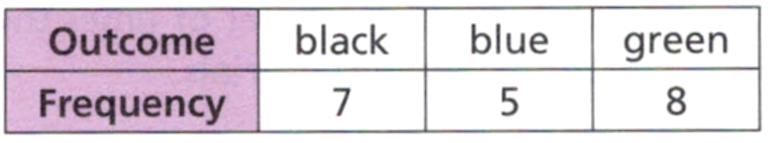
- A box contains black pens, blue pens and green pens. Abdullah selects a pen at random, notes its colour then puts it back in the box. He does this 20 times. The results are shown in the table.

  - Explain why the relative frequency of selecting a blue pen is 0.25.
$$\frac{5}{20}=\frac{1}{4}=0.25$$
  - What is the relative frequency of selecting a pen that is
    - Black?
$$\frac{7}{20}=0.35$$
    - Green?
$$\frac{8}{20}=\frac{2}{5}=0.4$$
  - What do you notice about the sum of your relative frequencies?
Adds up to 1. The proportion of every outcome adds up to 100%
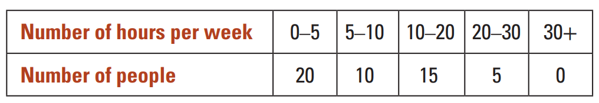
- A survey is conducted on people’s television viewing habits.

  - How many people participated in the survey?
50
  - What is the relative frequency of a participant watching less than 5 hours of television?
$$\frac{2}{5}$$
  - What is the relative frequency of a participant watching 5–20 hours of television?
$$\frac{1}{2}$$
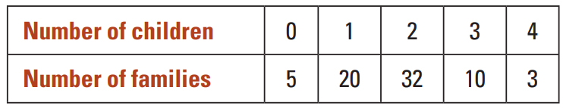
- The number of children in some families is recorded in the table shown.

  - How many families have no children?
5
  - How many families have an even number of children?
40
  - How many families participated in the survey?
70
  - Based on this experiment, what is the relative frequency of a family having an even number of children?
$$\frac{4}{7}$$
  - If 140 families were surveyed, how many would you expect to have an even number of children?
$$\frac{4}{7}×140=80$$

  - The relative frequency of a student throwing a pen in the bin is 0.5.
A student throws a pen 50 times. How many will be successful?

25
  - The relative frequency of a student throwing a pen in the bin is 0.1.
A student throws a pen 50 times. How many will be successful?

5
  - The relative frequency of a student throwing a pen in the bin is 1.
A student throws a pen 50 times. How many will be successful?

50
  - The relative frequency of a student throwing a pen in the bin is 0.1.
A student throws a pen 100 times. How many will be successful?

10
  - The relative frequency of a student throwing a pen in the bin is 0.900.
A student throws a pen 100 times. How many will be successful?

90
  - The relative frequency of a student throwing a pen in the bin is 0.15.
A student throws a pen 100 times. How many will be successful?

15
  - The relative frequency of a student throwing a pen in the bin is 0.015.
A student throws a pen 100 times. How many will be successful?
1.5

Development
- Complete the frequency tables and include the relative frequency.
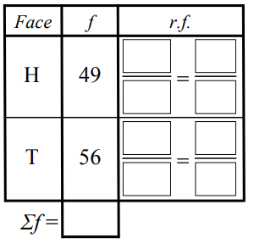  - Coin toss results  $$\frac{49}{105}=\frac{7}{15}$$  $$\frac{56}{105}=\frac{8}{15}$$  105 | 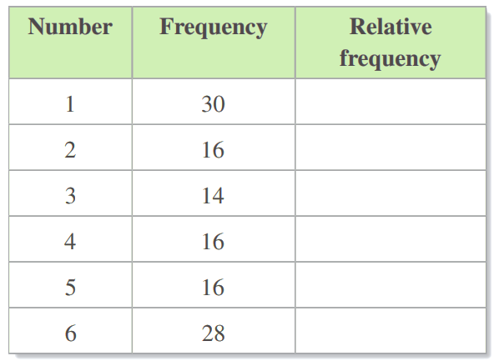  - Dice roll results  $$1/4$$  $$2/15$$  $$7/60$$  $$2/15$$  $$2/15$$  $$7/30$$
- The table shows how many products a store sold in a day. Complete the table.
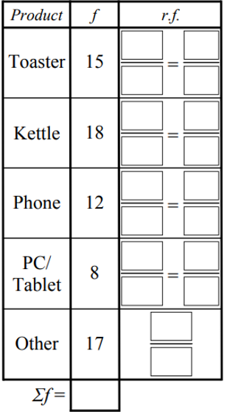
Based on the data, if 350 products were sold,
how many would be:
$$\frac{15}{70}=\frac{3}{14}$$
- Toasters?  $$\frac{3}{14}×350=75$$ | - Phones?  $$\frac{6}{35}×350=60$$ | $$\frac{18}{70}=\frac{9}{35}$$  $$\frac{12}{70}=\frac{6}{35}$$  $$\frac{8}{70}=\frac{4}{35}$$
- Kettles or toasters?  $$\frac{9}{35}×350=90$$  $$90+75=165$$ | - Not toasters?  $$350-75=275$$

$$\frac{17}{70}$$

- The table to the right shows how many products a store sold in a day.
Pete is running a promotion next week and expects to sell 1300 items.
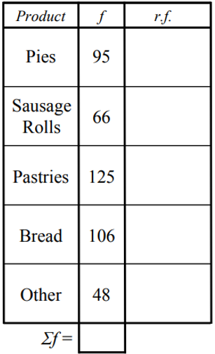
How much of each product should he make?
Round to the nearest whole.
- Pies  281 | - Sausage Rolls  195 | $$\frac{95}{440}$$  $$\frac{66}{440}$$  $$\frac{125}{440}$$  $$\frac{106}{440}$$  $$\frac{48}{440}$$
- Pastries  369 | - Bread  313
- Other

142
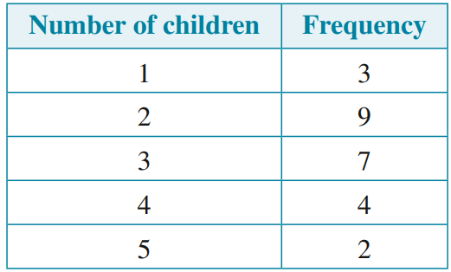
- The numbers of children in the families of a class of students are summarised in the given frequency distribution table.

  - What is the relative frequency of a family having 3 children?
$$\frac{7}{25}$$
  - If 100 families were surveyed, how many families would you expect to have 3 children?
$$28$$
  - What is the relative frequency of a family having 4 children?
$$\frac{4}{25}$$
  - If 500 families were surveyed, how many families would you expect to have 4 children?
80

- A fair dice is rolled 20 times, and an odd number is rolled every time.
Explain why the 21st roll is equally likely to be either odd or even.

The chance of odd and even for a fair die is always $\frac{1}{2}$
- A bag contains red, green, and blue marbles.
A marble is selected and replaced from the bag 20 times. The results are:
Red: 8 Green: 10 Blue: 2
Answer these questions using your relative frequency knowledge.
  - There are more red marbles than blue. True False Can’t tell
Can’t tell
  - There are 20 marbles in the bag. True False Can’t tell
Can’t tell
  - Are there definitely more green marbles than blue marbles? Yes No
no
  - Is it possible that there are more marbles blue than green or red? Yes No
yes

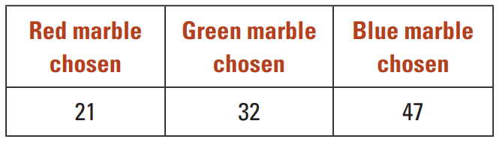
- A handful of 10 marbles of different colours is placed into a bag. A marble is selected at random, its colour recorded and then returned to the bag. The results are presented in the table.

  - Based on this experiment, how many marbles of each colour do you think there are? Justify your answer mathematically.
Using relative frequencies:
$$Red=\frac{21}{100}×10≈2, Green=\frac{32}{100}×10≈3, Blue=\frac{47}{100}≈5$$
  - For each of the following, state whether it is a possible set of colours for the 10 marbles.
    - 3 red, 3 green, 4 blue
yes
    - 2 red, 4 green, 4 blue
yes
    - 2 red, 3 green, 4 blue, 1 purple
yes
    - 2 red, 0 green, 8 blue
no
- NAPLAN Band 7
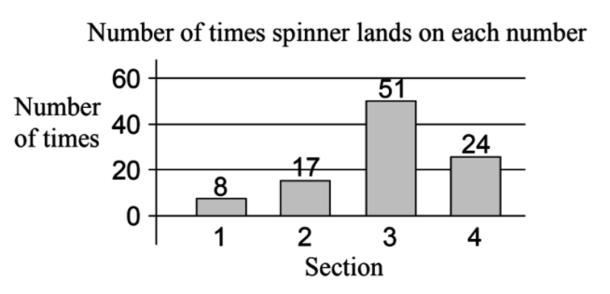
A spinner can land in any of 4 sections, labelled 1 to 4.
The spinner is spun 100 times and the results are recorded in the bar chart below.
Which of these spinners is most likely to give results shown in the graph?
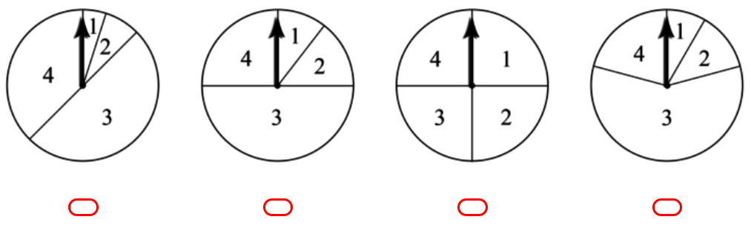

B, 3 is around half and 4 is around a quarter.
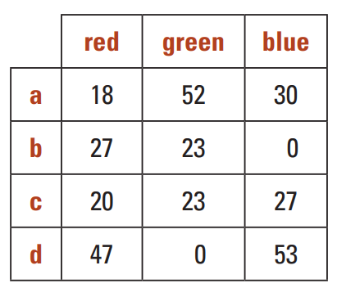
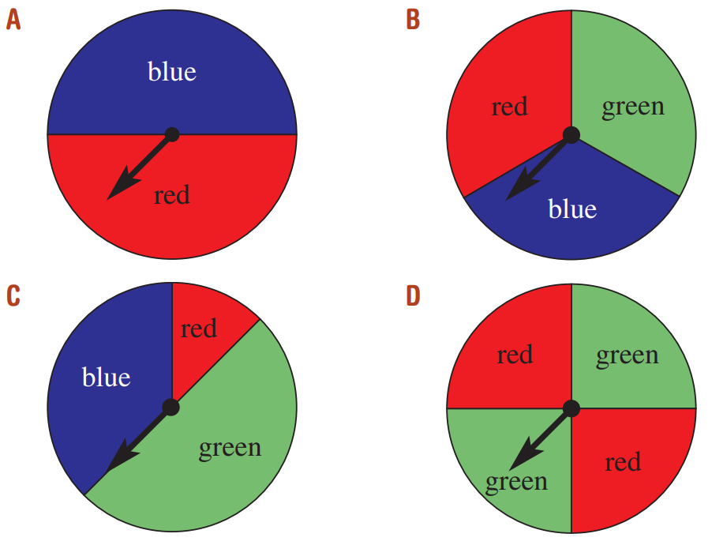
- Match each of the experiment results a to d with the most likely spinner that was used (A to D)

a – C, b – D, c – B, d – A

Mastery
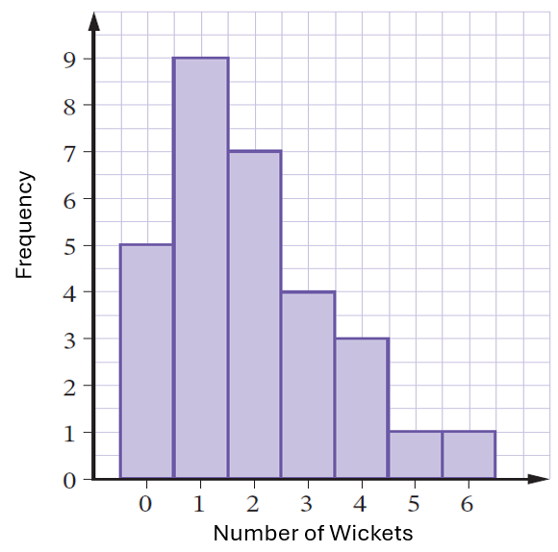
- The graph shows the frequency of wickets taken in a match of cricket.
What is the relative frequency of bowling
2 wickets in a match?

$$\frac{7}{30}$$
- NAPLAN A
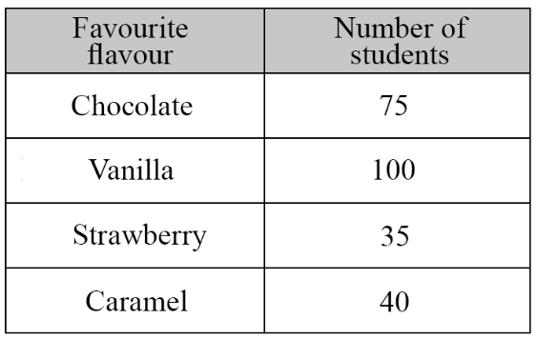
Which flavour did 4 out of 10 students choose as their favourite?

$$\frac{4}{10}×250=100$$
Vanilla
- NAPLAN A
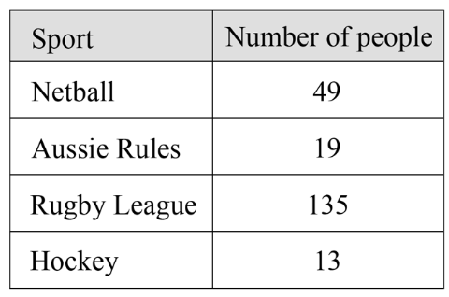
Based on the survey, predict how many people would choose rugby if 2000 people were surveyed.

$$\frac{135}{216}×2000=1250$$
- 2012 HSC Standard 2 Band 5
A spinner with different coloured sectors is spun 40 times. The results are recorded in the table.
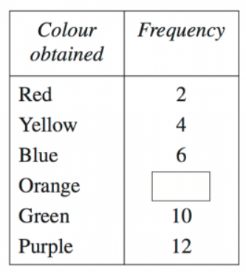
What is the relative frequency of obtaining the colour orange, as a decimal?

Frequency of orange = 40 – (the rest) = 6
$$\frac{6}{40}=\frac{3}{20}=0.15$$
- 2018 HSC Standard 2 Band 5
Jeremy rolled a biased 6-sided die a number of times. He recorded the results in the table.
How many times would he expect to roll a 3 if he rolled the dice 1500 times?
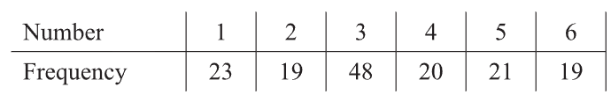

$$\frac{48}{150}×1500=480$$
- 2011 HSC Standard 2 Band 5
A die was rolled 72 times. The results for this experiment are shown in the table.
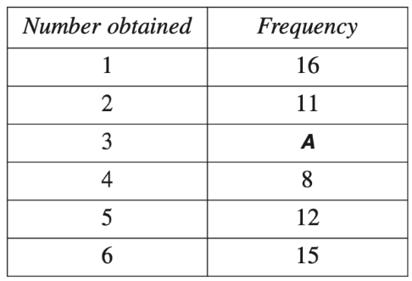
  - Find the value of A

10
  - What was the relative frequency of obtaining a 4?

$$\frac{8}{72}=\frac{1}{9}$$
  - If the die was unbiased, which number was obtained the expected number of times?
You expect each outcome $72×\frac{1}{6}=12$ times
5 was obtained expected number of times

- 2008 HSC Standard 2 Band 5
A die has faces numbered 1 to 6. The die is biased so that the number 6 will appear more often than each of the other numbers. The numbers 1 to 5 are equally likely to occur.
The die was rolled 1200 times and it was noted that the 6 appeared 450 times.
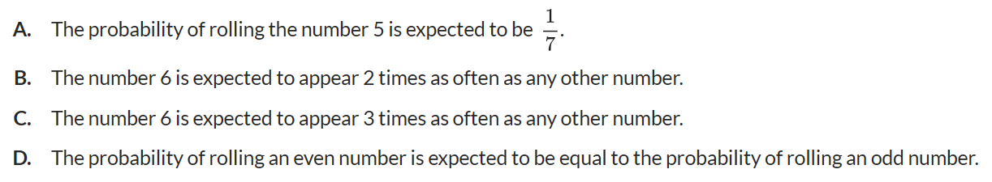
Which statement is correct?

$$rf of 6=\frac{450}{1200}=\frac{3}{8}$$
Therefore, all the other numbers have probability $\frac{5}{8}$, so each of the other numbers have probability $\frac{1}{8}$
C

Law of Large Numbers

- Investigation The Law of Large Numbers
A standard 6-sided die is rolled.
- List the set of possible outcomes: ……………………………
- What is the theoretical probability of each outcome? ……………………
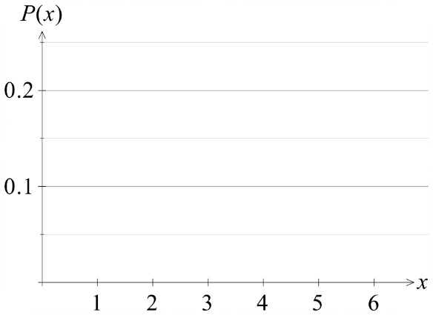
- Draw a histogram of the outcomes and their probabilities.

- What would you expect to happen if you roll a dice 6 times, according to the theoretical probabilities?

- https://mrdingmaths.github.io/LawofLargeNumbers/
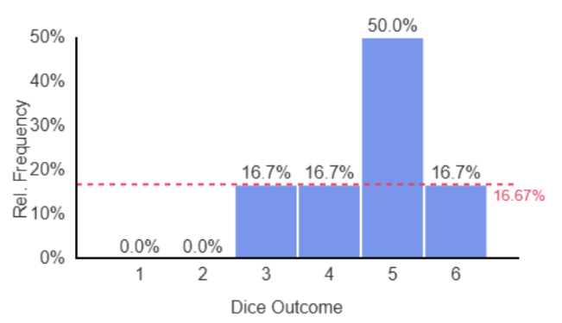  6 rolls | 100 rolls  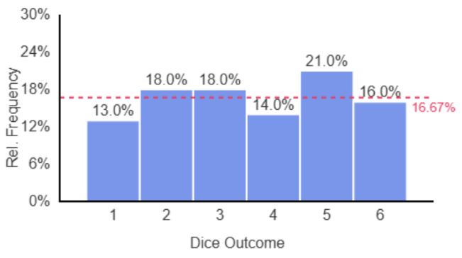
1000 rolls  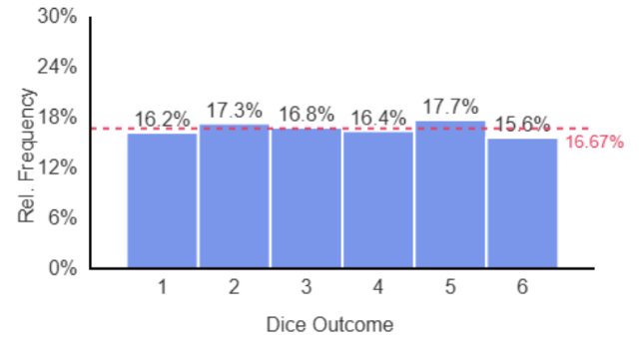 | 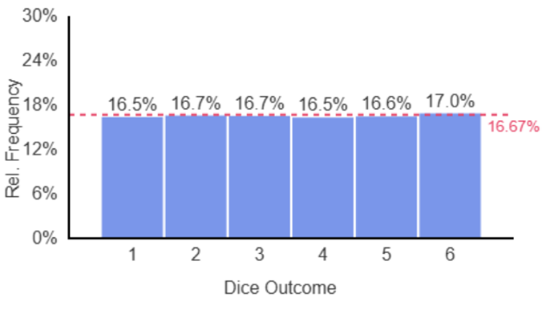  50000 rolls

- Law of Large Numbers
As number of trials increase, relative frequency approaches theoretical probability.

- Interpret The Law of Large Numbers
The result of a single random experiment is u……………………
With few trials, randomness means the relative frequency differs to the
t……………………… p…………………………
The Law of Large Numbers says that as you ………………… the number of trials, the relative frequency gets closer to the theoretical probability.
Therefore, if we don’t know the theoretical probability of an outcome, we can repeat an experiment many times and use the ……………… ………………… as an estimate for the theoretical probability. This is called observed probability.
The ……………… trials, the better the estimate.

- Experiment A: 10 coins are flipped.
Experiment B: 200 coins are flipped.
The relative frequency of getting heads and tails of each experiment is calculated.
Which survey would have relative frequency closest to the theoretical probability?
a | Experiment A | b | Experiment B | c | They would be the same. | d | Impossible to say.

- One day Nicole sees 6 cars pass her house. 2 of which are blue.
Nicole says: I estimate probability of seeing a blue car pass my house is $\frac{2}{6}$
How can she improve her estimate?
a | Simplify her fraction | b | Watch more cars and record her results | c | Find more blue cars | d | Go to a different house and repeat the observations

Complementary Events

- Complementary Events
- Complementary events cover all possible outcomes.
- The complement of an event is the event not taking place.

- Identify complement of an event
The event is rolling a 3 on a fair six-sided die.  The complementary event is:  not rolling a 3: {1,2,4,5,6} | A bag contains red, green, and blue marbles. The event is picking red or blue.  The complementary event is:  Not picking red or blue: {green}
Identify the complement of these events.
- Sunny day tomorrow. | - Winning a game of table tennis.
- Rolling an even number on a fair six-sided die. | - Picking fruit from a box containing chocolates, lollies, and fruit.

- Key Ideas
- The complement of an event is the event ………… happening.
- The event and its complement cover …………… possible outcomes.

Foundation
- Determine the complement of each event.
  - Tossing a tails on a coin.
Not tossing a tails / tossing a heads
  - Cloudy day tomorrow.
Not a cloudy day tomorrow
  - Rolling a 6 on a die.
Not rolling a 6 /
  - Winning a game of OzTag.
Not winning a game of OzTag / drawing or losing a game of OzTag
  - Selecting a heart from a deck of cards.
Not selecting hearts / selecting diamond, club, or spade
  - Being born in Winter.
Not being born in winter / born in spring, summer, or autumn
  - Being under 15 years old.
Not being under 15 years old / being 15 or older

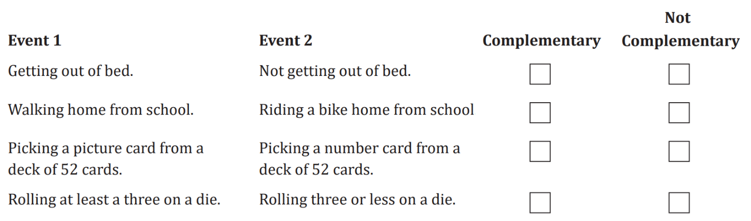
- Identify whether these are complementary events.
C
NC
C
NC
- Explain why the following are not complementary events
  - ‘sunny day’ and ‘rainy day’.

There are more than two possible outcomes for the weather
  - ‘winning a game’ and ‘losing a game’.
Depending on the game, it may be possible to draw (like chess).

Using the Complement in Probability Problems

- Review
- Number bonds to 1
- $1-0.6$ | - $1-0.45$ | - $1-(0.3+0.4)$
- $1-\frac{5}{7}$ | - $1-\frac{2}{6}-\frac{1}{6}$ | - $1-\left(\frac{3}{10}+\frac{1}{5}\right)$

- Solve equations
- $x+0.2=1$ | - $x+\frac{3}{4}=1$ | - $2x+0.6=1$
- $x+0.2+0.7=1$ | - $x+\frac{1}{4}+\frac{1}{2}=1$ | - $2x+\frac{2}{5}=1$

- Complementary Probabilities
- Complements simplify the sample space to two events.
- The probability of an event not happening is written as $P\left(E^{'}\right)$ or $P\left(\overline{E}\right)$, meaning $P(not E)$.
- The probability of an event and its complement sum to 1.
$$P\left(E\right)+P\left(\overline{E}\right)=1 \\ P\left(\overline{E}\right)=1-P(E)$$

- Example Using complementary outcomes in problem-solving
A pack of 20 cards contains 10 blue, 3 yellow, 3 red, and 4 green.
One card is drawn from the pack.
Find the probability that the card is green.  $$P\left(G\right)=\frac{4}{20}=\frac{1}{5}$$ | Find the probability that the card is not green.  $$P\left(\overline{G}\right)=1-P\left(G\right) \\ =1-\frac{1}{5} \\ =\frac{4}{5}$$
In using $1-P\left(G\right)$ instead of $P\left(B\right)+P\left(Y\right)+P\left(R\right)$, we only had to calculate ……… probability instead of three. The more ………… there are, the more time saved.

- Guided Practice
- The probability of it raining is 0.2. What is the probability that it doesn’t rain?

0.8
- A pack of 20 cards contains 10 blue, 6 yellow and 4 green.
One card is drawn from the pack. Find the probability that the card is not yellow.

$$\frac{7}{10}$$
- A bag of 25 coloured cubes contains 3 colours.
You know there are 7 green cubes.
What is the probability of picking a cube that is not green?

$$\frac{18}{25}$$

- Key Ideas
- The complement of an outcome is the outcome ………… happening.
- The probability of an outcome and the outcome not happening must sum to ……………
- We can calculate the $P(\overline{E})$ by ………………… $P(E)$ from 1.

Foundation
- The probability that it will rain this weekend is $\frac{8}{10}$.
What is the probability that it won’t rain?
$$\frac{2}{10}$$
- The probability of a bus arriving on time is 75%.
What is the probability the bus does not arrive on time?
25%
- Levon buys 5 tickets in a raffle of 1000 tickets.
What is the probability that he doesn’t win?
$$\frac{995}{1000}$$
- There are 11 cards, 6 of which are red. What is the probability of not selecting a red card?
$$\frac{5}{11}$$
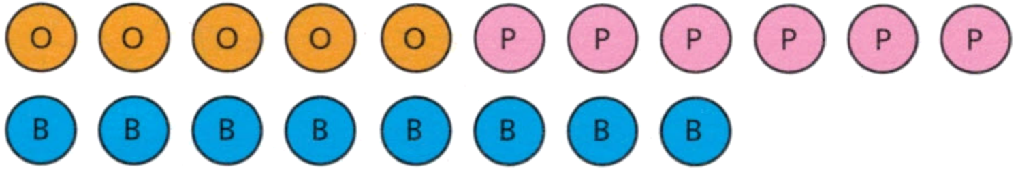
- Here are some counters

A counter is selected at random. Calculate these probabilities,
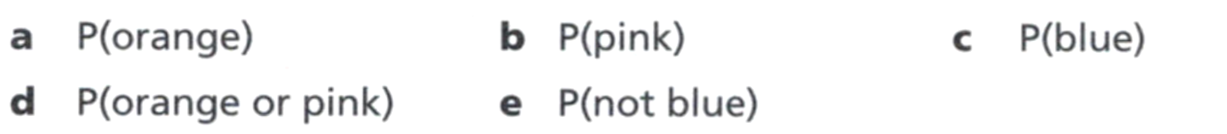  $$\frac{5}{19}$$ | $$\frac{6}{19}$$ | $$\frac{8}{19}$$
$$\frac{11}{19}$$ | $$\frac{11}{19}$$

- A car park has 450 cars, 100 motor bikes, and 10 buses. One is selected at random.
  - What is the probability that it is a car?
$$\frac{45}{56}$$
  - What is the probability that it is not a car?
$$\frac{11}{56}$$
- The letters of the word PROBABILITY are written on separate cards and one is selected a randomly. Calculate:

  - $P\left(Selecting P\right)$
$$\frac{1}{11}$$
  - $P\left(Not selecting P\right)$
$$\frac{10}{11}$$
  - $P\left(Selecting I\right)$
$$\frac{2}{11}$$
  - $P(Not selecting I)$
$$\frac{9}{11}$$

Development
- Complete this table.
Event | $$P\left(event\right)$$ | $$P\left(not event\right)$$ | Sum of probabilities
Rolling a fair 6-sided die and getting 3 | $$\frac{1}{6}$$ | $$\frac{5}{6}$$ | 1
Tossing a coin and getting heads | $$\frac{1}{2}$$ | $$\frac{1}{2}$$ | $$1$$
Rolling a fair 6-sided die and getting 2 or 5. | $$\frac{1}{3}$$ | $$\frac{2}{3}$$ | $$1$$
Selecting a letter from ‘HEART’ and getting a vowel | $$\frac{2}{5}$$ | $$\frac{3}{5}$$ | $$1$$
- If the probability of selecting a vowel in a particular word is $\frac{3}{13}$,
what is the probability of selecting a consonant?
$$\frac{10}{13}$$
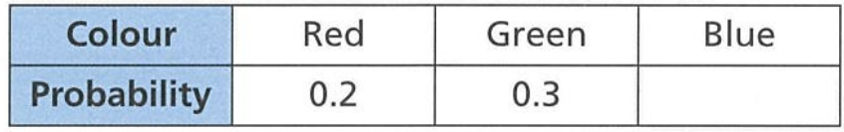
- A spinner has different 3 different coloured sections.

What is the probability of spinning blue?
0.5
- William plays soccer. The table shows the probability that he will win, lose or draw.
Work out the missing probability.
$\frac{1}{2}$ | 0.6
  Win | Lose | Draw
  $$\frac{1}{4}$$ | $$\frac{1}{4}$$
  Win | Lose | Draw
  $$0.2$$ | $$0.2$$
0.67 | 0.23
  Win | Lose | Draw
  $$0.3$$ | $$0.03$$
  Win | Lose | Draw
  $$0.7$$ |  | $$0.07$$

- Calculate $P(not 2)$ for each of these spinners as a simplified fraction.
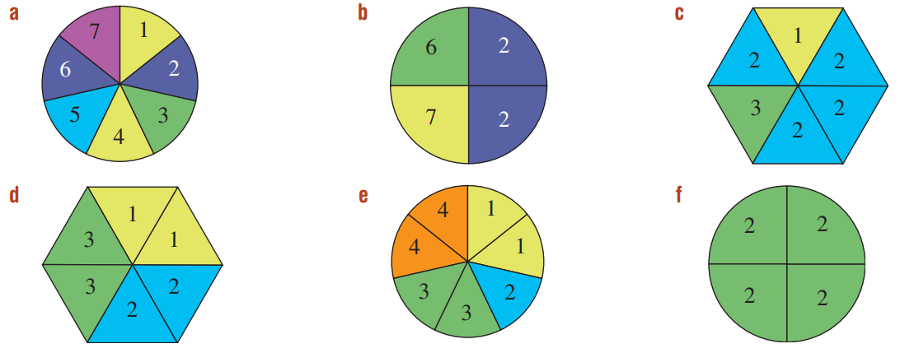  $$\frac{6}{7}$$ | $$\frac{1}{2}$$ | $$\frac{1}{3}$$
$$\frac{2}{3}$$ | $$\frac{6}{7}$$ | 0

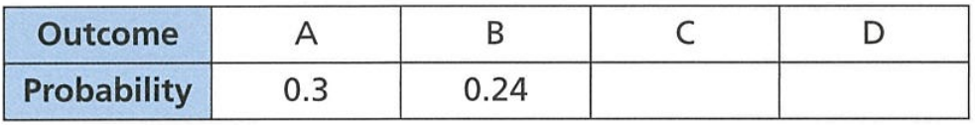
- The probability of each outcome, A to D, is shown in the table.

The probability of outcome C is the same as outcome D.
What is the probability of getting outcome B or C?
Let probability of C and probability of D be $x$
$$0.3+0.24+x+x=1$$
$$x=0.23$$
$$P\left(B or C\right)=0.24+0.23=0.47$$
- The table shows the probabilities of three different outcomes.
Explain why this table of outcomes must be incorrect.
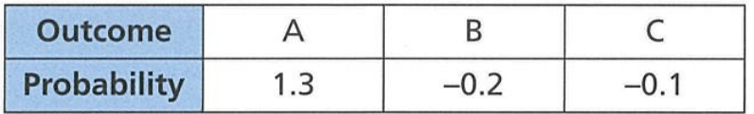

Probability can’t be negative
- A bag contains marbles. When one marble is chosen at random from the bag, the probability that it is red is $\frac{7}{19}$ and the probability that it is blue is $\frac{4}{19}$. What is the probability that it is neither red nor blue?

$$\frac{8}{19}$$
- A bag contains coins. When a coin is chosen at random from the bag, the probability that it is $1 is $\frac{3}{10}$ and the probability that it is $2 is $\frac{2}{5}$. What is the probability that it is not a gold coin?
$$\frac{3}{10}$$

Mastery
- A spinner with three colours (black yellow white) is constructed with these probabilities:
$P\left(Black\right)=0.2$ $P\left(Yellow\right)=0.4$
  - Calculate $P\left(not black\right)$
0.8
  - Calculate $P\left(white\right)$
0.4
  - Explain why $P(not black nor yellow)$ is the same as $P(white)$ with reference to complementary events.

Since there are only 3 colours, not black nor yellow is the same as white
as they are complementary events.
- Two teams play a game of football.
The probability that team A wins is 0.3.
The probability that team B wins is 0.23.
What is the probability of a draw?

0.47
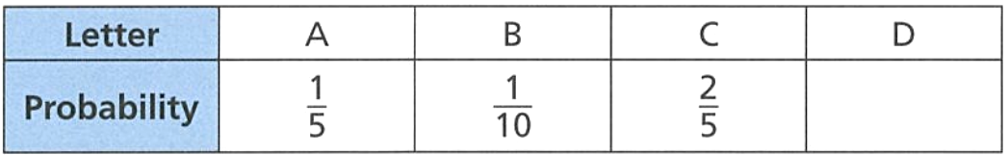
- A spinner has 20 sections. Each section is labelled A, B, C or D.
The table shows the probability of spinning each of the letters.

  - What is the probability of spinning the letter A or B?
$$\frac{3}{10}$$
  - What is the probability of spinning the letter D?
$$\frac{3}{10}$$
  - How many sections are labelled C?
8
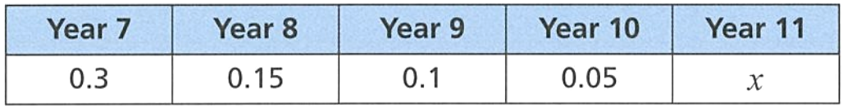
- The table shows the probabilities of students being picked at random from each year group.
A student is selected at random. Find these probabilities.
  - P(Year 11)
0.4
  - P(Year 7 or Year 8)
0.45
  - P(not Year 9)
0.9
- A fair six-sided dice is rolled. What is the probability of not rolling a factor of 6?

$$\frac{1}{3}$$
- There are 50 marbles in a bag. What is the probability of getting a white marble?
Give your answer as a percentage.

28%
- A box contains different coloured counters, with
P(purple) = 10%, P(yellow) = $0.\dot{6}$ and P(orange) = $\frac{1}{7}$.
Is it possible to obtain a colour other than purple, yellow or orange? If so, state the probability.

Yes, as the probabilities don’t sum to 1.
- A bag contains blue, green, and red counters.
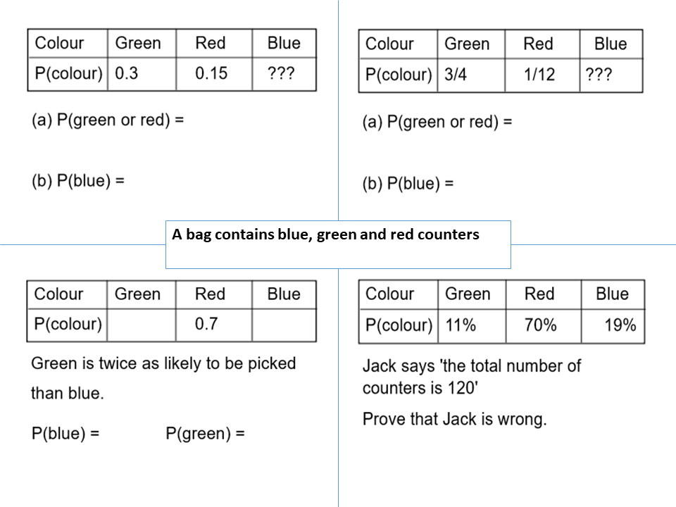  P(green or red)  0.45  P(blue)  0.55 | P(green or red)  $$\frac{5}{6}$$  P(blue)  $$\frac{1}{6}$$
Green is twice as likely to be picked than blue  P(green)  0.2  P(blue)  0.1 | P(green or red)  88%  P(blue)  19%  P(not green nor red)  19%  What do you notice?  Not green nor red is the same as blue

- A bucket containing a number of counters with four different colours (green, blue, orange, and red) are picked out of a container. The following probabilities are given.
- $P\left(green\right)=$ $\frac{6}{15}$
- $P\left(blue\right)=$ $\frac{1}{5}$
- $P\left(red\right)=$ $\frac{1}{3}$
For this question, write all the probabilities as fractions:
  - State the event complementary to picking blue.
Not blue
  - Calculate $P\left(B^{'}\right)$
$$\frac{4}{5}$$
  - Calculate $P(O)$
0
  - Calculate $P(O^{'})$
1
- 2015 HSC Standard 2 Band 4
The table shows the relative frequency of selecting each of the different coloured jelly beans from packets containing green, yellow, black, red and white jelly beans.
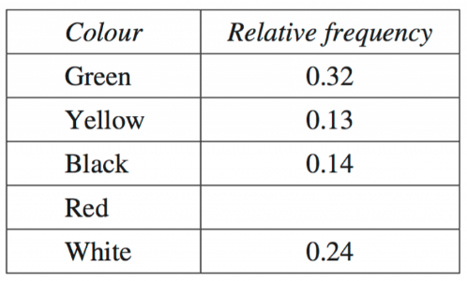
  - What is the relative frequency of selecting a red jelly bean?

0.17
  - Based on this table of relative frequencies, what is the probability of NOT selecting a black jelly bean?

0.86
- 2005 HSC Standard 2 Band 4
There are 100 tickets sold in a raffle. Justine sold all 100 tickets to five of her friends. The number of tickets she sold to each friend is shown in the table.
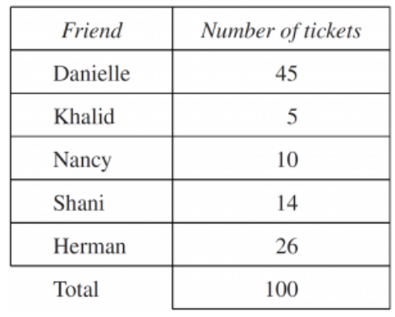
  - Justine claims that each of her friends is equally likely to win first prize.
Give a reason why Justine’s statement is NOT correct.

Each person has a different number of tickets
  - What is the probability that first prize is NOT won by Khalid or Herman?

$$\frac{69}{100}$$

